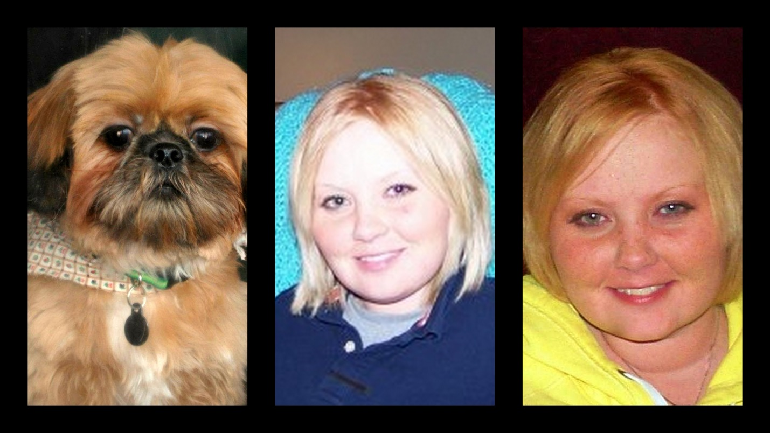**Katie Wertz Memorial Scholarship Fund: (2012)** Annual scholarship in the amount of $500 awarded to one senior at Sentinel Career Center with a passion for performing volunteer work within the community.

**Criterion for Selection:**  Candidate must be a current senior enrolled at Sentinel Career Center planning on pursuing a post-secondary degree. Candidate must have recently demonstrated a genuine act of humanity within his / her community.

**Application & Nomination Process:** The candidate will fill out the attached application and have two (2) letters of recommendation submitted to Sentinel Career Center by March 31. The application MUST be filled out completely. Each letter of recommendation should clearly outline how the candidate has gone above and beyond in giving back to their community and why it is important to the candidate.

**Award Selection:**  All applications will be reviewed and a winner will be announced at the Sentinel Awards Ceremony.

**Application**

Full Name (Last, First MI) ______________________________________________________________________

Address ___________________________________________________________________________________

City / State / Zip ________________________________________ Phone ___________________________________

Area of Focus (Sentinel) _______________________________________________________________________

High School _________________________________________________________________________________

Post-Secondary School ________________________________________________________________________

Major __________________________________ Minor (if applicable) ______________________________________

Recent Volunteer Activities (within 2 years) _________________________________________________________

______________________________________________________________________________________________________________________________________________________________________________________________________________________________________________________________________________________________________

On a separate page, please write an essay, in 500 words or less describing your passion for volunteer work and how it will play a role in your future.